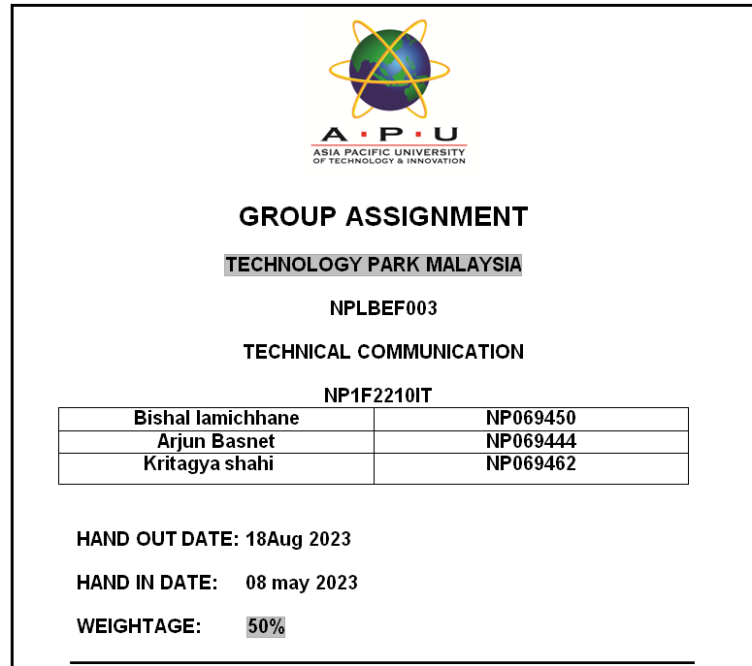

COVER LETTER

Arjun Basnet

Project Manager

XEROX IT Pvt. Ltd

Kathmandu

20th august 2023

T0,

The Arena Group

Kathmandu

Subject: Proposal for Implementing an Innovative Management Analytical System

Dear sir/Madam,

I hope you are healthy and happy when you receive this letter. I'm really happy to promote XEROX IT Pvt. Ltd. and our innovative solution, which is designed to take your management analytical systems to new heights.

At XEROX IT Pvt. Ltd., we are experts at developing cutting-edge IT solutions that not only satisfy the changing needs of organisations but also promote long-term expansion. We have carefully considered the goals and difficulties facing The Arena Group, and we are convinced that our solution will greatly improve your business.

At XEROX IT Pvt. Ltd., our staffs has a wealth of experience in providing tailored IT solutions, utilising data analytics for wise decision-making, and using an innovation-driven strategy to develop cutting-edge solutions. We have a track record of completing projects successfully in a variety of industries, so we are sure we can put this revolutionary approach in place for your business.

We are aware of how crucial financial concerns are, and we provide transparency and a good return on your investment by factoring numerous project phases into our budget estimation. Beyond financial gains, our solution has the potential to increase revenue, reduce costs, and provide a long-lasting competitive edge, thus the projected return on investment goes beyond financial gains.

Please give us your blessing so that we can start implementing this management analytical system at "The Arena Group." Our staff is glad to collaborate closely with you to achieve a smooth execution that supports your strategic objectives.

We appreciate your interest in XEROX IT Pvt. Ltd. as a partner in this innovative and forward-thinking journey. We are eager to talk about this concept in more detail and address any concerns you might have.

Sincerely,

Arjun Basnet

XEROX IT Pvt. Ltd

Implementing an IT Analytical System at "The Arena Group"

# Company Profile:

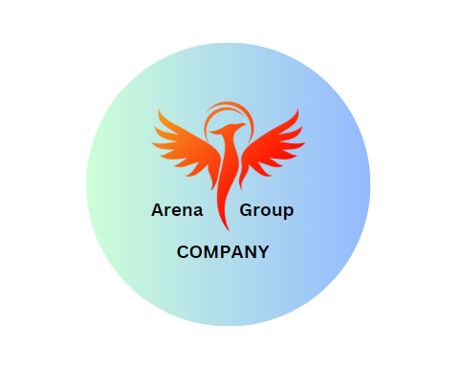

A well-known business, The Arena Group is renowned for providing great services in the areas of branding, marketing, and event management. The Arena Group has made a name for itself as a reliable partner for clients looking for excellence and expertise by focusing on providing top-notch services.

Event management is one of The Arena Group's primary specialties. The Arena Group is exceptional in producing unique experiences, whether for corporate events, conferences, or product launches. Their team of event specialists guarantees that every aspect is painstakingly planned and executed flawlessly from conception to execution. The Arena Group strives to consistently go above and beyond client expectations because they recognise the value of producing memorable events that leave an impression on attendance.

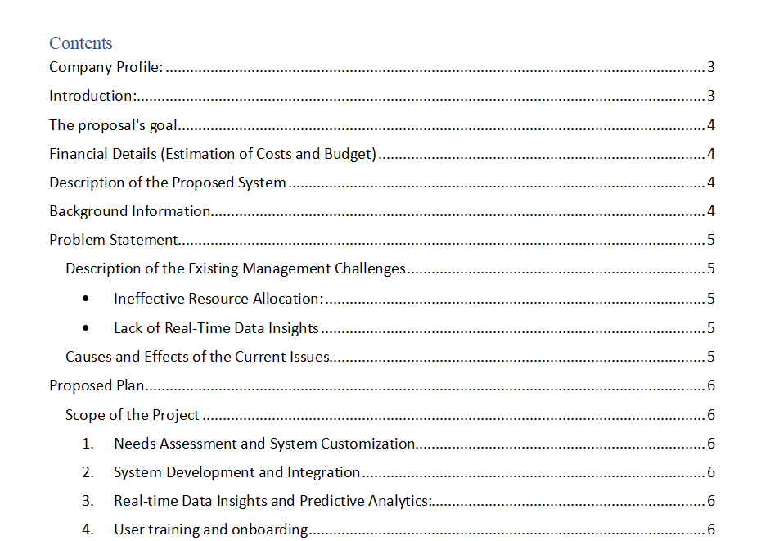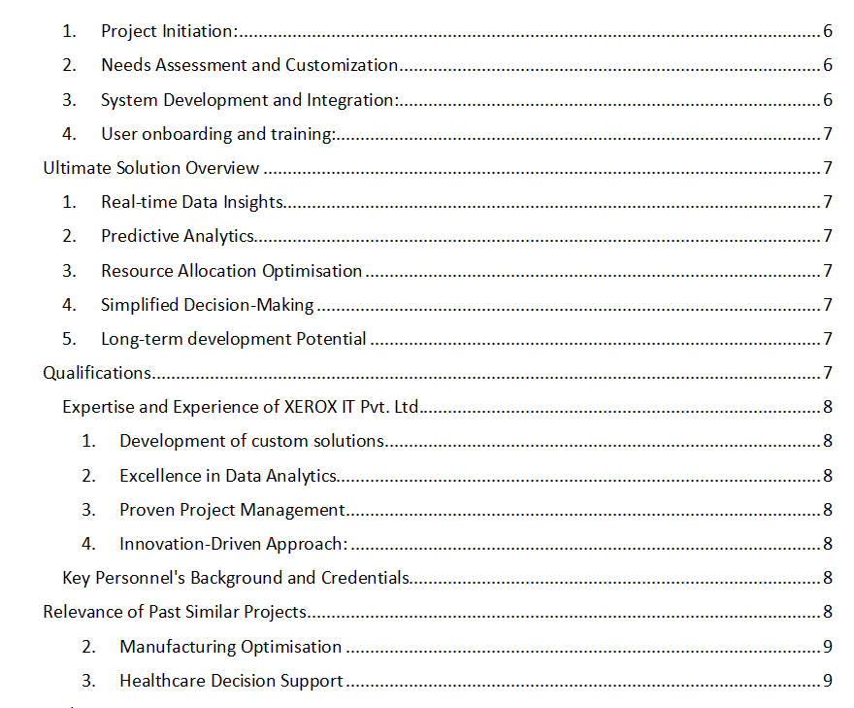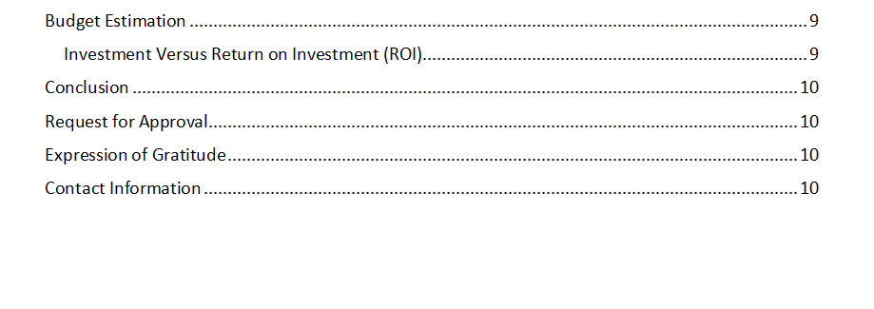

# Introduction:

This proposal's main goal is to implement a revolutionary management analytical system at "The Arena Group." The difficulties you currently encounter with streamlining your management procedures and enhancing operational effectiveness are carefully addressed by this solution. Adopting this cutting-edge technology will enable your organisation to use real-time data insights to improve decision-making, expedite resource allocation, and boost overall business performance.

# The proposal's goal

This proposal seeks to provide "The Arena Group" with the opportunity to implement a cutting-edge management analytical system that will fundamentally alter how you approach resource management and decision-making. We want to underline how effectively solving your difficulties with our recommended solution may also boost your company's productivity and foster long-term growth.

# Financial Details (Estimation of Costs and Budget)

An initial investment is required for the development, integration, training, and continuing support necessary for the implementation of this ground-breaking management analytical system. Our in-depth cost-benefit analysis demonstrates that the initial costs are significantly outweighed by the long-term benefits of superior decision-making, resource allocation, and operational performance. (Eby, The Ultimate Guide to Project Cost Estimating, 2017)

The implementation of the management analytical system at "The Arena Group" involves several key components, each contributing to the overall success of the project. The following is a detailed breakdown of the estimated budget for the project:

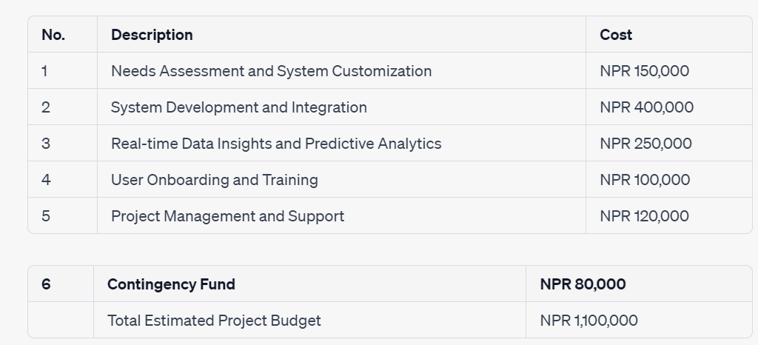

# Description of the Proposed System

Modern software was used to develop our suggested management analytical system in order to meet the specific needs of "The Arena Group." You are able to quickly gather, analyse, and analyse data from a variety of sources with the aid of this system, which readily integrates with your current infrastructure. To provide your team with valuable information, the solution offers user-friendly dashboards, customizable reports, and predictive analytics.

Your decision-makers will be able to measure key performance indicators, keep an eye on market trends, and predict future situations, giving them the tools they need to make educated decisions that support business success. The system's user-friendly interface also ensures a smooth onboarding process so that your personnel may utilise it to the fullest extent right away.

# Background Information

"The Arena Group" has received praise for its commitment to industry excellence for a long time. However, as the market evolves and competition heightens, there is a greater demand for data-driven decision-making and efficient resource management. Traditional management techniques are insufficient to sustain a competitive edge in the fast-paced business world of today.

"The Arena Group" is searching for novel solutions to these problems in order to streamline its administrative processes and promote growth. Because the organisation understands the importance of the digital transformation, it is committed to using technology to enhance operational effectiveness, customer satisfaction, and overall business performance.

# Problem Statement

At the moment, "The Arena Group" has a lot of work to do to run its business efficiently and make wise decisions. The lack of a strong management analytical framework has resulted in reactive decision-making, inefficient resource allocation, and missed growth possibilities. The business needs to tackle these issues and put a revolutionary solution in place in order to maintain its competitive edge and benefit from new market trends.

## Description of the Existing Management Challenges

* Ineffective Resource Allocation: "The Arena Group" has trouble making the best use of all of its resources, including money, people, and time. As a result, resources are misallocated, projects are delayed, and operations costs rise. The business is unable to allocate resources strategically to meet its objectives without reliable insights into resource utilization.
* Lack of Real-Time Data Insights: The organization is unable to acquire real-time data insights due to the lack of a centralized management analytical system. Decision-making is hampered by the reliance on manual data collecting and fragmented systems. The company's capacity to react quickly to market developments and make proactive decisions is hampered by this lack of access into crucial data. (FarEye, 2022)

## Causes and Effects of the Current Issues

* Cause: Fragmented Data Sources: It is difficult to integrate and analyse the company's data because it is dispersed across numerous departments and systems. Data silos created by this fragmentation prevent cross-functional collaboration and an all-encompassing perspective of the business.
* Effect: Decision-makers lack access to a thorough picture of how things are going. As a result, choices are made based on insufficient information, which may not be consistent with the overall strategy of the firm.
* Cause: Manual Data Entry and Analysis Employees are forced to rely on manual data entry and analysis due to the lack of an automated analytical system. This wastes time and is error-prone, producing erroneous findings.
* Effect: Management spends too much time gathering and validating data, which takes attention away from making strategic decisions. The company's competitive positioning is impacted by its failure to react quickly to market changes.

# Proposed Plan

Our suggested strategy calls for the seamless installation of a thorough management analytical system adapted to "The Arena Group's" unique requirements. By offering real-time data insights, predictive analytics, and optimised resource allocation, this solution seeks to address the problems described in the problem statement. The project will be carried out in stages to minimise disturbance to your continuing business operations and to maximize the advantages of the new system.

## Scope of the Project

The following significant elements are included in the project's scope:

1. Needs Assessment and System Customization: We will thoroughly analyse the needs and problems of your firm. This evaluation will serve as a roadmap for tailoring the management analytical system to fit your particular operations, processes, and strategic goals.
2. System Development and Integration: To ensure a flawless integration with your current infrastructure, our skilled development team will design and build the management analytics system. Centralised data sources will make it possible to collect, analyse, and analyse data quickly.
3. Real-time Data Insights and Predictive Analytics: Using user-friendly dashboards and adaptable reports, the system will offer real-time data insights. The ability to identify industry trends and prospective possibilities thanks to predictive analytics will enable proactive decision-making.
4. User training and onboarding: We're devoted to giving your staff all the tools they need to take use of the system's features. To acquaint users with the UI, data visualisation tools, and sophisticated analytics features, thorough training sessions will be held.

# Steps of Implementation

1. Project Initiation: This stage involves launching the project, coordinating stakeholders, and establishing project goals. The roles and duties of both teams will be clearly defined, and we will set up effective communication routes.
2. Needs Assessment and Customization: Our professionals will interact with your team to comprehend the unique requirements of your business and will modify the system as necessary. The mapping of data sources and integration points is another aspect of this phase.
3. System Development and Integration: Our development team will plan and create the management analytical system using cutting-edge technologies. To ensure smooth data flow, integration with current systems and databases will be painstakingly carried out.
4. User onboarding and training: When the system is prepared, we will hold in-depth training sessions to acquaint your team with its features, navigation, and functionality. This phase is essential to ensuring that your team can utilise the system's features to the fullest. (Asana, 2022)

# Ultimate Solution Overview

Our recommended final solution is a state-of-the-art management analytical system that will give "The Arena Group" the following abilities:

1. Real-time Data Insights: The system's user-friendly dashboards and adaptable reports offer a live view of crucial business measurements and KPIs.
2. Predictive Analytics: The system will forecast market trends, consumer behaviour, and demand changes using historical data and sophisticated algorithms, enabling proactive decision-making.
3. Resource Allocation Optimisation: The system will enable data-driven resource allocation, enabling your business to manage cash, labour, and time in the most effective way possible, resulting in increased effectiveness and lower costs.
4. Simplified Decision-Making: Your decision-makers will have the tools necessary to make well-informed decisions quickly, ensuring that your business remains nimble and competitive.
5. Long-term development Potential: "The Arena Group" will be well-positioned for sustained development, operational excellence, and industry leadership by embracing data-driven strategies and developing an innovative culture.

# Qualifications

XEROX IT Pvt. Ltd. is a renowned pioneer in the area of cutting-edge IT solutions. Our team has a history of providing cutting-edge technological solutions to a range of industries, and we have the knowledge and skills required to complete this project effectively. We are devoted to using our resources to guarantee the smooth implementation of the suggested management analytical system for "The Arena Group."

## Expertise and Experience of XEROX IT Pvt. Ltd.

1. Development of custom solutions: Our staff is skilled in creating IT solutions that are specifically suited to solve particular business problems. We have successfully completed a variety of projects, from customer relationship management platforms to enterprise resource planning systems, all of which were created to improve business operations.
2. Excellence in Data Analytics: Our data analytics team has a solid grasp of data administration, analysis, and visualisation. We have assisted businesses in using their data to obtain useful insights that have facilitated strategic planning and informed decisions.
3. Proven Project Management: Based on best practises, our project management processes guarantee effective project execution, prompt delivery, and adherence to quality standards. No matter how complex the project, we are committed to exceeding the expectations of the client.
4. Innovation-Driven Approach: Here at XEROX IT Pvt. Ltd., we're dedicated to keeping on the cutting edge of technical development. Because of our creative thinking, we consistently research new technologies to develop cutting-edge solutions.

## Key Personnel's Background and Credentials

1. Bishal lamichhane - CEO and Project Lead: With over 15 years of experience in IT solutions delivery, Bishal has overseen numerous successful projects across diverse industries. Her leadership has been instrumental in driving XEROX IT Pvt. Ltd.'s reputation for innovation and excellence.
2. Kritagya shahi- Chief Data Scientist: He holds a Ph.D. in Data Science and has an extensive background in predictive analytics and machine learning. He has led data-driven initiatives that have delivered remarkable outcomes for organizations seeking to harness the power of data.
3. Arjun Basnet - Project Manager: Arjun proficiency in project management ensures that our projects are executed flawlessly, from initiation to delivery. His strong communication skills and attention to detail guarantee that projects are delivered on time and within scope.

# Relevance of Past Similar Projects

Our track record of completing similar projects successfully demonstrates our capacity to use technology to alter businesses: (Oostdam, 2016)

1. Retail Analytics System: For a well-known chain of stores, we put in place a retail analytics system that gives real-time insights into customer behaviour, inventory control, and sales patterns. Improved inventory turnover and greater customer satisfaction were the outcomes. (Retail Analytics System, 2006)
2. Manufacturing Optimisation: For a manufacturer, we created a comprehensive system that streamlined resource allocation and production procedures. Both operational costs and productivity were significantly reduced for the organisation.
3. Healthcare Decision Support: We created a decision support system for the healthcare industry that allowed medical professionals to make deft judgements based on patient data. This resulted in better patient outcomes and more effective resource management.

# Budget Estimation

We are aware of the importance of financial factors in your decision-making. Our open and thorough budget estimation takes into account the numerous elements required for the planned management analytical system's effective implementation. Here is a thorough summary of expenses: (Eby, The Ultimate Guide to Project Cost Estimating, 2017)

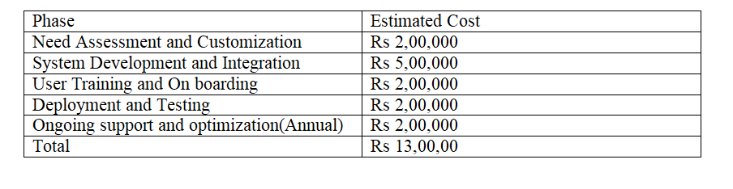

## Investment Versus Return on Investment (ROI)

We recognize that any investment in technology should yield tangible benefits and a positive return on investment. Implementing the proposed management analytical system offers substantial returns that extend beyond financial gains: (Team, 2023)

1. Increased operational efficiency will lead to lower expenses thanks to data-driven decision-making, streamlined resource allocation, and real-time insights. (BANTON, 2010)
2. Revenue Growth: Increased revenue and market share will result from the capacity to recognise market trends and seize new possibilities.
3. Cost Savings: Improved resource management and decreased operational inefficiencies will eventually result in cost savings.
4. Competitive Advantage: With a sophisticated system at their disposal, "The Arena Group" will have an advantage over rivals by acting quickly and intelligently.
5. Long-Term Sustainability: A data-driven strategy promotes an innovative culture and puts your business in a position for sustainable long-term growth. (Birken, 2005)

# Gantt chart:

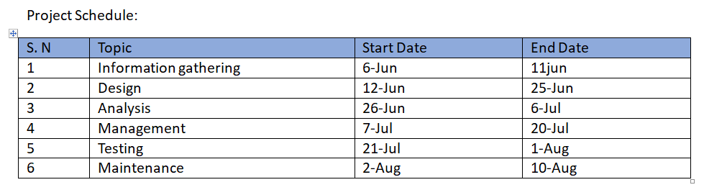

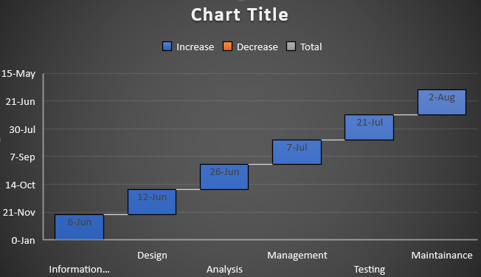

Flow chart:

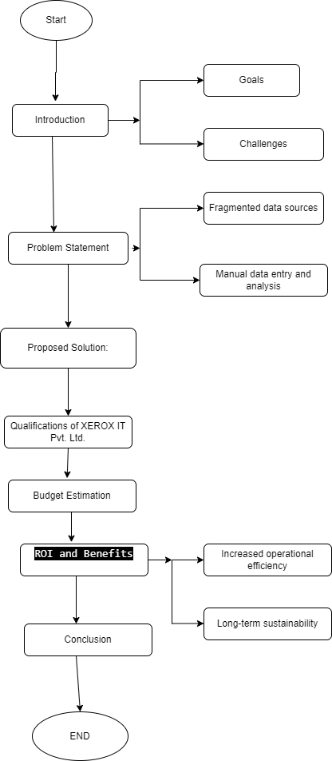

# Conclusion

In conclusion, "The Arena Group" has a critical chance to address its current issues and spur sustainable growth through the application of the suggested management analytical system by XEROX IT Pvt. Ltd. Your business can switch to a data-driven operating paradigm that encourages prompt, well-informed decision-making by seamlessly integrating real-time data insights, predictive analytics, and optimized resource allocation. This project is an important strategic investment in the long-term success of your business since it has the potential to significantly boost operational effectiveness, revenue growth, cost savings, and competitive advantage.

# Request for Approval

We respectfully ask for your consent to move forward with the planned management analytical system's deployment. This programme is positioned to be a game-changing move forward because of the synergy between our experience, "The Arena Group's" particular demands, and the anticipated return on investment. We can't wait to travel this path with you and work together to make sure that this ground-breaking project is realised successfully.

# Expression of Gratitude

We want to sincerely thank you for giving XEROX IT Pvt. Ltd. consideration for this important opportunity. We sincerely look forward to working together with "The Arena Group" to develop a unique solution that will open up new possibilities for operational effectiveness, strategic decision-making, and growth potential. We are grateful for your faith in our expertise and devoted to providing quality throughout the project.

# Contact Information

For any inquiries, clarifications, or further discussions, please do not hesitate to reach out to us using the contact information provided below:

**XEROX IT Pvt. Ltd.**

Kathmandu

Contact: [info@xeroxit.com](mailto:info@xeroxit.com)

Website: [www.xeroxit.com](http://www.xeroxit.com/)

We eagerly await your response and the opportunity to move forward with this project that holds the promise of transformative change for "The Arena Group." Thank you once again for considering XEROX IT Pvt. Ltd. as your partner in this exciting journey of innovation and growth.

Sincerely,

XEROX IT Pvt. Ltd.

Contact: xxxxx

# Bibliography

Asana. (2022, november 10). *What is an implementation plan*. Retrieved from https://asana.com/resources/implementation-plan.

BANTON, C. (2010). *Return on Investment (ROI)*. Retrieved from https://www.investopedia.com/articles/investing/111715/return-investment-roi-vs-internal-rate-return-irr.asp#toc-return-on-investment-roi.

Birken, E. G. (2005). *Return On Investment (ROI)*. Retrieved from https://www.forbes.com/advisor/investing/roi-return-on-investment/.

Eby, K. (2017, march 27). *The Ultimate Guide to Project Cost Estimating*. Retrieved from https://www.smartsheet.com/ultimate-guide-project-cost-estimating.

Eby, K. (2017, march 27). *The Ultimate Guide to Project Cost Estimating*. Retrieved from https://www.smartsheet.com/ultimate-guide-project-cost-estimating.

FarEye. (2022, october 13). *What is real-time visibility*. Retrieved from https://fareye.com/resources/blogs/real-time-visibility#:~:text=Lack%20of%20accurate%20real-time%20data%20and%20insights%20about,increasing%20transportation%2C%20damage%20to%20goods%2C%20and%20delayed%20deliveries.

Oostdam, A. W. (2016). Making history relevant to students by connecting past, present and future: a framework for research. *Journal of Curriculum Studies* .

*Retail Analytics System*. (2006). Retrieved from https://retalon.com/blog/retail-data-analytics.

Team, C. (2023). *Return on Investment (ROI)*. Retrieved from https://corporatefinanceinstitute.com/resources/accounting/what-is-return-on-investment-roi/.

# Appends:

Letter of Reference: XEROX IT Pvt. Ltd.

Email: [info@xeroxit.com](mailto:info@xeroxit.com)

To whom it may concern,

Dear Sir/Madam,

We are happy to give you a detailed proposal for an inventive management analytical system that has been specially crafted to satisfy the objectives of "The Arena Group." The chance to address your company's needs and offer a revolutionary solution that will greatly improve your business operations excites XEROX IT Pvt. Ltd. The proposal that our team of committed experts has painstakingly created illustrates the advantages, system assurance, cost projections, and the potential for IT innovation.

Software can be used to automate the management procedures in our suggested management analytical system. The Arena Group can better manage their operations, enhance their decision-making, and boost production with the aid of the technology. Our system comes with tools like data analytics, performance tracking, and reporting that are all made to give The Arena Group a complete picture of their business operations.

Our suggested management analytical method is economical and created to deliver a high return on investment in terms of budget estimation. We think that The Arena Group can increase overall profitability and accomplish their business objectives with the aid of our solution.

We would like to thank The Arena Group for giving us the chance to recommend their cutting-edge management analytics system. We think that The Arena Group can greatly enhance its operations and attain its business goals with the aid of our solution.

We are eager to collaborate with The Arena Group and ask for permission to move forward with the project. If you need more information or have any queries, don't hesitate to get in touch with us.

Sincerely,

XEROX IT Pvt. Ltd

